|  |  |
| --- | --- |
| Timekeeping Quick Reference Guide | |
| **Applicable To**: All DMI employees | **Approval Date**: 02/05/2015 |
| AUTHORIZED DOCUMENTS ARE PUBLISHED ONLINE ONLY. VERIFY ANY COPY AGAINST THE ONLINE SYSTEM BEFORE USE. | |

Table of Contents

1 Purpose and Scope 3

2 Description 3

3 References 3

4 Overview of Timesheet Policies 3

4.1 Leave Without Pay 4

4.2 Holiday Hours 4

5 Timekeeping Quick Reference Guide 4

5.1 Log In to Time & Expense 4

5.1.1 Reset Password 7

5.2 Navigate Time & Expense 9

5.3 Access and Navigate Timesheet 9

5.4 Record Time 11

5.4.1 Add Project Favorites Folder 13

5.4.2 Auto-Load Project Charge Code 13

5.4.3 Correct Saved Timesheet 14

5.4.4 Resolve Unavailable Charging 15

5.5 Sign Timesheet 16

5.6 Adjust Work Schedule 16

5.7 Correct Signed Timesheet 17

5.8 Charge Future Hours 18

5.9 View, Approve, or Reject Employee Timesheet 18

5.10 View Charge Activity 20

5.11 Correct Processed Timesheet 21

5.12 Request or Schedule Leave 21

5.13 Approve or Reject Leave 22

5.14 Cancel Requested Leave 25

6 Definitions of Acronyms and Terms 26

Document Revision History

| Revision History | Date | Summary of Changes | Author |
| --- | --- | --- | --- |
| 0.1 | 04/28/2014 | Created initial draft of guide, provided to QCoE | Finance Team |
| 0.2 | 05/01/2014 | Converted to QRG format, performed QA review | Laurie Doliber |
| 0.3 | 05/02/2014 | Performed peer review, addressed outstanding comments | Brian Hanrahan |
| 0.4 | 05/30/2014 | Addressed outstanding comment | Lori Bookhard |
| 0.5 | 05/30/2014 | Incorporated feedback | Laurie Doliber |
| 0.6 | 07/18/2014 | Added LWP, holiday, and reversal information | Laurie Doliber |
| 0.7 | 07/21/2014 | Provided feedback regarding reversal information | Shirley Campbell |
| 0.8 | 07/22/2104 | Incorporated feedback | Laurie Doliber |
| 1.0 | 07/25/2014 | Performed management review, provided feedback and approval | Beth Leonard, Paul Murray |
| 1.1 | 08/27/2014 | Added sections about submitting, approving, rejecting, and cancelling leave | Laurie Doliber |
| 1.2 | 08/27/2014 | Performed peer review, provided feedback | Janice Chiddo |
| 1.3 | 08/28/2014 | Incorporated feedback, performed QA review | Laurie Doliber |
| 1.4 | 08/29/2014 | Added screenshots for leave approval/rejection | Laurie Doliber |
| 1.5 | 08/29/2014 | Reviewed and approved additions | Janice Chiddo |
| 2.0 | 08/29/2014 | Performed management review/approved | Beth Leonard |
| 2.1 | 02/05/2015 | Updated access instructions for new site format and DMI SHARE | Laurie Doliber |
| 3.0 | 02/05/2015 | No change to intent of guide, re-baseline without formal review | Kate Tennant |

Record of Acceptance/Approval

|  |  |  |
| --- | --- | --- |
| Chief Financial Officer | | |
| Printed Name: **Paul G. Murray** |  | Date: |
| Signature: |  |  |
| Director of Corporate Quality Assurance | | |
| Printed Name: **Kate Tennant** |  | Date: |
| Signature: |  |  |

# Purpose and Scope

This quick reference guide provides instructions for entering, updating, and approving timesheets. These instructions apply to all DMI employees.

# Description

DMI uses Deltek Costpoint for accounting and finance. Deltek has a web-based, integrated timekeeping system called Time & Expense 9 (T&E), which enables DMI to do away with paper timesheets. This integrated timesheet system streamlines the processes for completing and submitting timesheets, clarifies DMI’s timesheet policies, and provides Defense Contract Audit Agency (DCAA) compliance.

* **NOTE**: For mobile timekeeping, DMI uses Deltek’s GovCon Time & Expense mobile application. Refer to the *DMI Mobile Timesheet Application Quick Reference Guide* for more information.

# References

Referenced documents related to this quick reference guide are as follows:

* *DMI Mobile Timesheet Application Quick Reference Guide*
* Employee handbook

# Overview of Timesheet Policies

Here are a few things to keep in mind concerning DMI timesheets:

* **Minimum Hours Required for Exempt Employees**: All exempt employees **MUST** enter at least 8 hours times the number of work days in the pay period. If you do not meet the minimum target hours for the pay period, you must use your paid time off (PTO).
* **Compensatory (Comp) Time for Exempt Employees**: DMI does **NOT** provide compensatory time to exempt employees. Flextime (adjusting work hours within a single pay period) is permitted.
* **Absenteeism/Tardiness**: If you are absent for three or more consecutive workdays due to an illness, a physician’s note is required.
* **DCAA Compliance**: Keep this document, along with your employee handbook, at your worksite at all times. These documents together make up part of your time reporting information file as required by the DCAA.

If you would like more information on DMI’s policies, review our *Employee Handbook* located on the Automatic Data Process (ADP) website at [https://portal.adp.com/Employee_Handbook](https://portal.adp.com/static/clients/content/Employee_Handbook_V4_03-2012.pdf?1389643423237). If you still have questions, contact human resources (HR) or your supervisor.

## Leave Without Pay

Salaried exempt employees must use leave without pay (LWP) in **8-hours increments ONLY**. This is because the Department of Labor (DOL) has a federal law that says it is unlawful to dock an exempt employee for less than a 1-day absence.

When entering LWP on a timesheet, add **TWO charge** **lines** **per day** to the timesheet as follows:

1. For commercial employees:
2. Fringe DMI/Leave Without Pay, 04100.LWP, LW1 – enter **8 hours** per day
3. Fringe DMI/NEGATIVE Leave Without Pay, 04100.LWP, LW2 – enter **-8 (minus) hours** per day
4. For non-commercial (all remaining) employees:
5. Fringe DMI/Leave Without Pay, 04000.LWP, LW1 – enter **8 hours** per day
6. Fringe DMI/NEGATIVE Leave Without Pay, 04000.LWP, LW2 – enter **-8 (minus) hours** per day

The first line ensures the cost is applied correctly for the week for any auto-adjusted employee. The second line balances out the hours and reduces the salary by the amount of pay associated with the timesheet line.

* **NOTE**: Your timesheet will NOT meet the target hours if using LWP.

## ****Holiday Hours****

If you took a holiday off of work, charge 8 hours to Fringe DMI/Holiday, 04000.HOL, H, in **8-hours increments ONLY**.

If you are required to work on the holiday, charge hours to the applicable project. If, when signing your timesheet, you encounter an error, you may need to adjust your work schedule. Refer to section 5.6 for detailed instructions.

# Timekeeping Quick Reference Guide

The following subsections detail the timekeeping procedures.

## Log In to Time & Expense

To access the T&E application, complete the following.

1. Open the Internet Explorer web browser.
2. In the address (uniform resource locator (URL)) field, enter [**https://timesheets.dminc.com/DeltekTC/welcome.msv**](https://timesheets.dminc.com/DeltekTC/welcome.msv).

**–OR–**

1. From the DMI SHARE, click the **HR** tab, scroll down, and in the Quick Links section, click **Deltek Time Collection E-Time**.

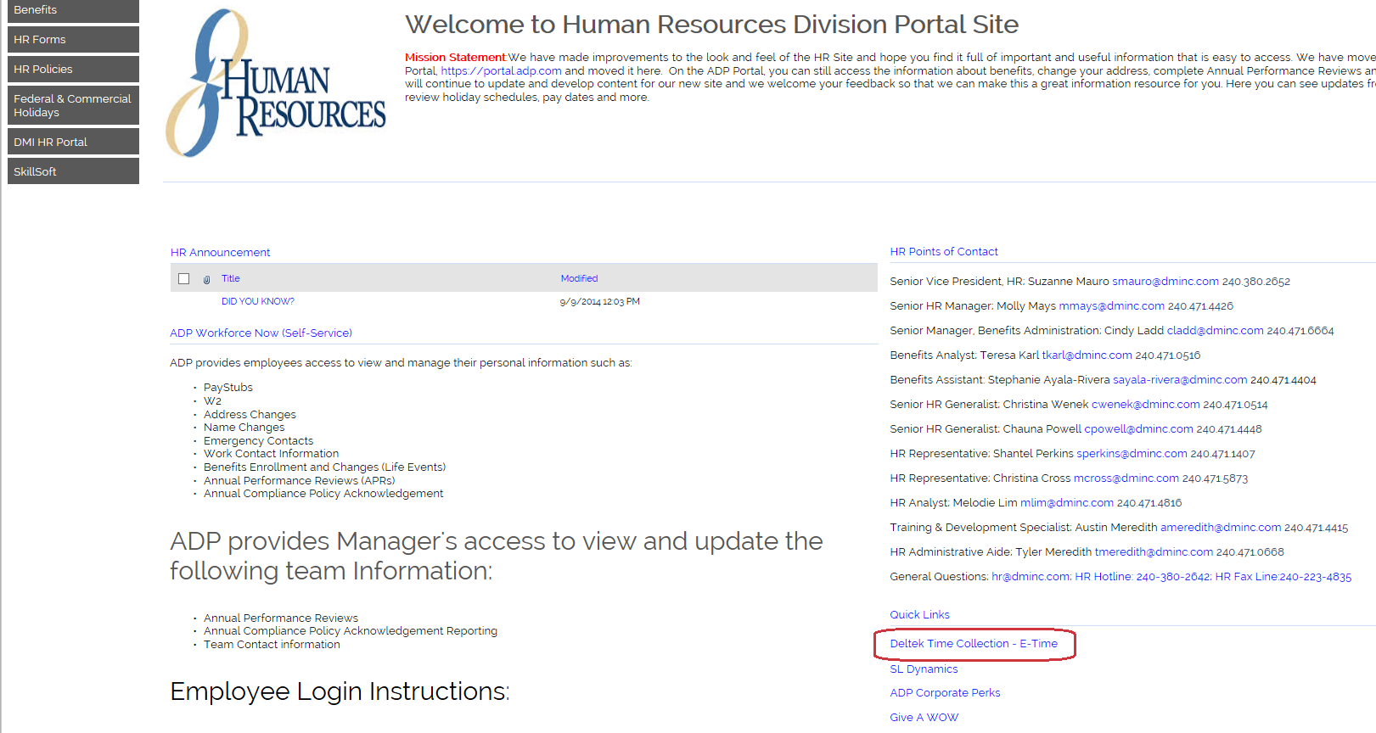

Figure –: HR Tabbed Page, Quick Links

1. In the Deltek Time & Expense window, in the Login ID field, enter **[your ID]**.

* **NOTE**: Your login ID is your first initial and last name, in ALL CAPS (e.g., JDOE). The ID is case sensitive.

1. In the Password field, enter your **[password]**.

* **NOTE**: The default password is your date of birth in YYYYMMDD format.

1. In the Domain field, enter **DMI**.

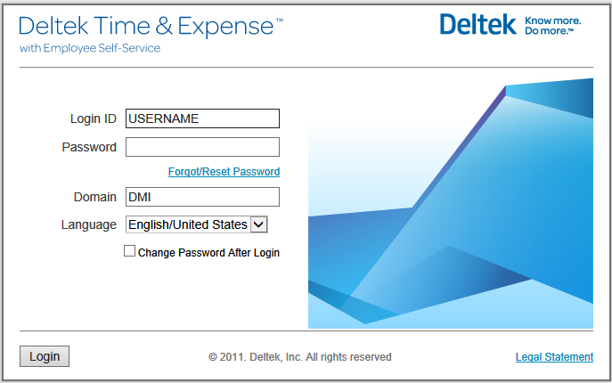

Figure –: Deltek Login Window

1. Click **Login**.
2. If this is the initial log in, using your default password, Deltek immediately prompts you to change your password.
3. In the Change Password window, in the New Password field, enter a **[password]**.
4. In the Verify Password field, reenter the **[password]**.

* **NOTE**: Passwords must be at least six characters long and contain at least one number, one upper case letter, and one lower case letter.

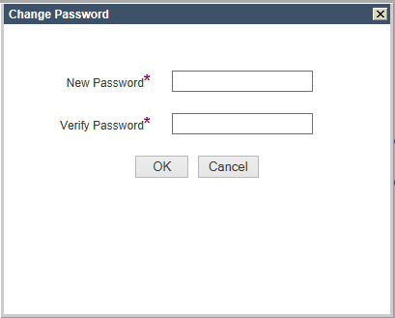

Figure –: Change Password Window

1. Click **OK**.
2. In the Answer field, enter the **[response to the security question]**.
3. Click **Submit**.

* **CAUTION**: If you forget your password, refer to section 5.1.1.

### Reset Password

To reset a password, complete the following:

1. In the Deltek Time & Expense window, click the **Forgot/Reset Password** link.
2. In the Password Self Reset window, verify the **login ID** and **domain** and click **Next**.

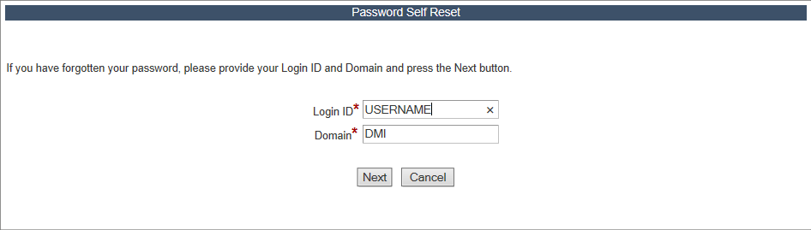

Figure –: Password Self Reset, Verify Login ID and Domain

1. In the Answer field, enter the **[response to the security question]**.

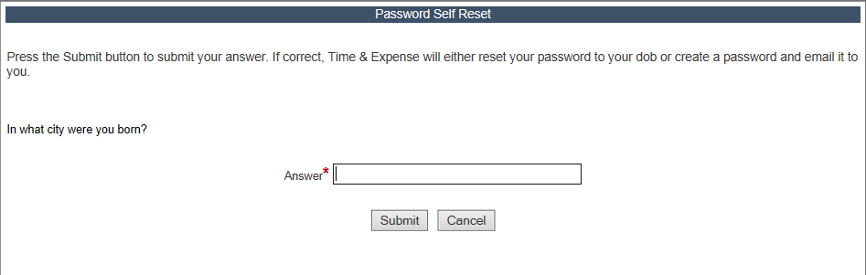

Figure –: Password Self Reset, Answer Security Question

1. Click **Submit**.
2. To acknowledge that your password has been reset to your date of birth (DOB), in YYYYMMDD forma, click **Continue**.

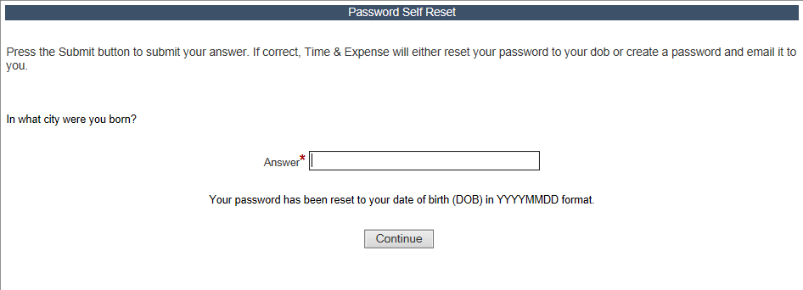

Figure –: Password Self Reset, DOB Confirmation

1. In the Change Password window, in the New Password field, enter a **[password]**.
2. In the Verify Password field, reenter the **[password]**.

* **NOTE**: Passwords must be at least six characters long and contain at least one number, one upper case letter, and one lower case letter.



Figure –: Change Password Window

1. Click **OK**.
2. In the confirmation window, click **OK**.

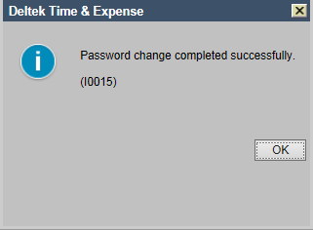

Figure –: Change Password Confirmation Window

## Navigate Time & Expense

The My Desktop window displays any tasks currently requiring completion, and lists recent timesheets. At any time, clicking the  icon brings you back to the My Desktop window.

## Access and Navigate Timesheet

To access and navigate your timesheet, complete the following:

1. In the My Desktop window, in the My Timesheets section, click the **latest timesheet date**.

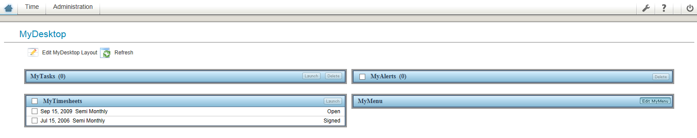

Figure –: My Desktop Window

1. Alternatively, click **Time** in the upper left corner
2. In the left navigation, expand **Record Time**, and click **Timesheet**.

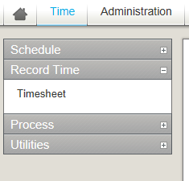

Figure –: Record Time Option

1. In the Timesheet window, view the following key data:

* **Employee** – Name and Employee ID
* **Status** – Current status of timesheet
* **Revision** – Current version of timesheet starting from 1
* **Class** – Employment classification
* **Semi Monthly Period** Ending – Last day of the pay period

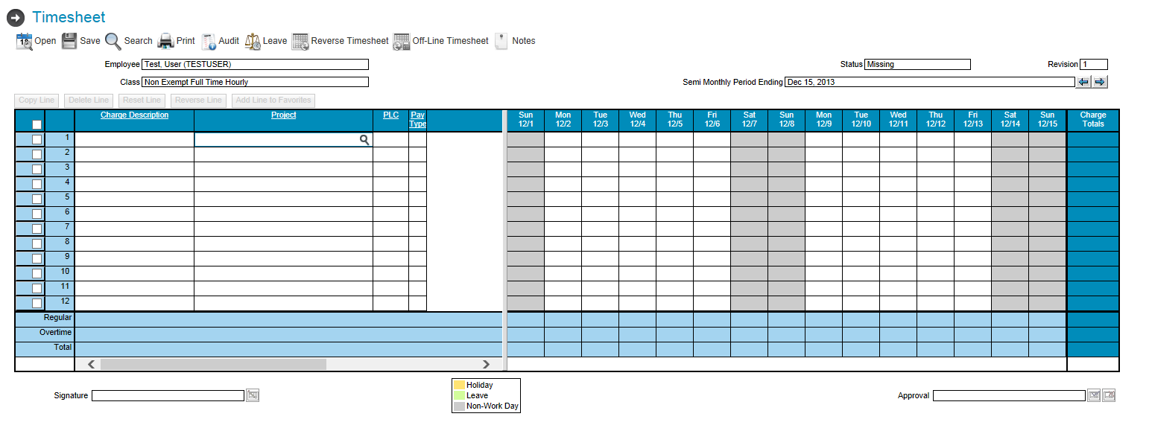

Figure –: Timesheet Window

1. To move between timesheet periods, click the  **toggle** links.
2. In the control bar, use the following options to perform actions related to timekeeping:

* **NOTE**: Available options are dependent upon the status of your timesheet and your security role. Unavailable options are grayed out.
* **Open** – Opens the calendar so you can find the timesheet you wish to view
* **Save** – Saves the displayed timesheet
* **Search** – Enables a supervisor to open the selected employee’s timesheets
* **Print** – Prints the timesheet
* **Audit** – Shows all saved changes made to the timesheet
* **Leave** – Shows the current running balance of PTO
* **Reverse Timesheet** – Used to create a timesheet correction



Figure –: Timesheet Control Bar

## Record Time

To record time, complete the following:

1. In the Project column, click the **magnifying glass** icon.
2. In the Charge Lookup window, click **Execute** to see the project charge codes you are authorized to use.

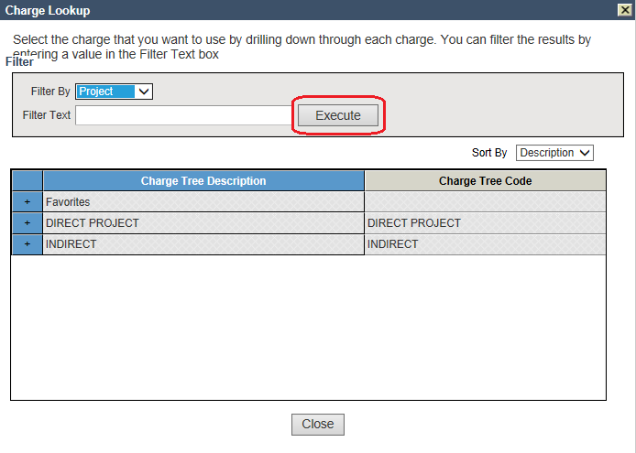

Figure –: Execute Lookup

1. Locate the project for charging, and select the **corresponding** check box.

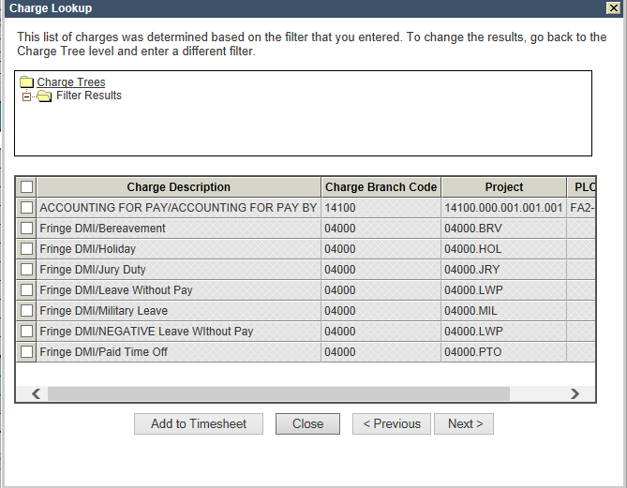

Figure –: Charge Lookup Window

1. Click **Add to Timesheet**.

* **NOTE**: To add multiple lines at once, select **multiple** check boxes.

1. In the Timesheet window, select the appropriate **day** and enter **[your hours worked]**.

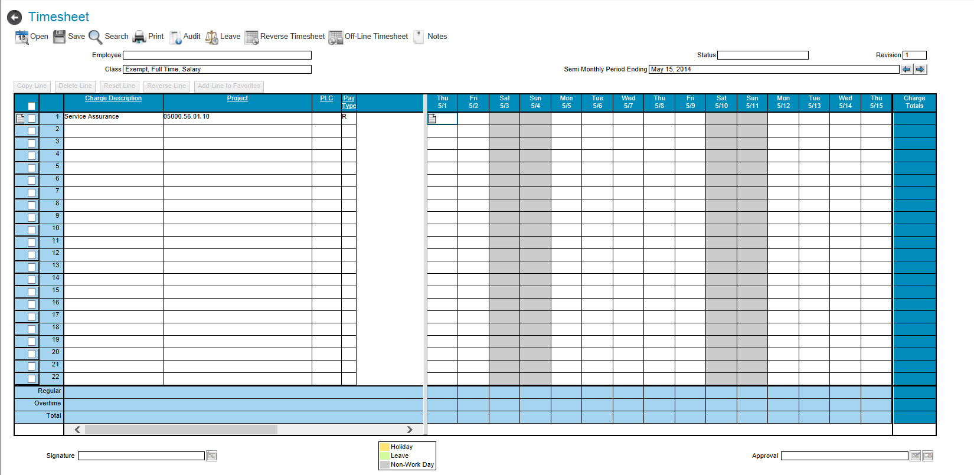

Figure –: Timesheet Window, Enter Hours

1. To enter comments, in the day cell, click the **comment** 🗋 link.
2. In the Cell Comment window, enter **[comments]**.
3. Click **OK**.

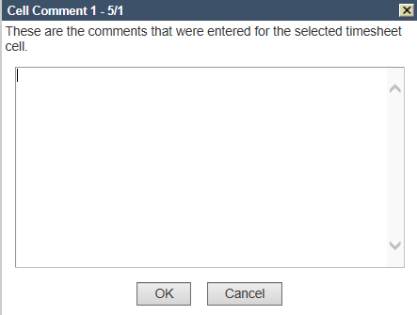

Figure –: Cell Comment Window

1. In the Timesheet window, click **Save**.

* **NOTE**: After charges and hours have been entered you must save your timesheet in order for the data to be recorded. The timesheet should only be saved when you are satisfied with the entries made.

1. In the confirmation window, click **OK**.

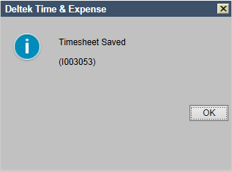

Figure –: Confirmation Window

* **NOTE**: If a saved timesheet needs to be changed, make the necessary changes and save the timesheet again.

### Add Project Favorites Folder

To add a project to the Favorites folder, complete the following:

1. In the Timesheet window, select the **project line** check box.

* **NOTE**: The menu just above the timesheet grid becomes enabled.

1. Click **Add Line to Favorites**.



Figure –: Add Line to Favorites

### Auto-Load Project Charge Code

If you routinely use the same projects each pay period, and have added it to your Favorites folder, you can have the project automatically displayed on the timesheet. To auto-load a project charge code, complete the following:

1. In the Charge Lookup window, expand the **Favorites** folder.



Figure –: Charge Lookup Window

1. Select the **Load** check box.
2. Click **Update**.

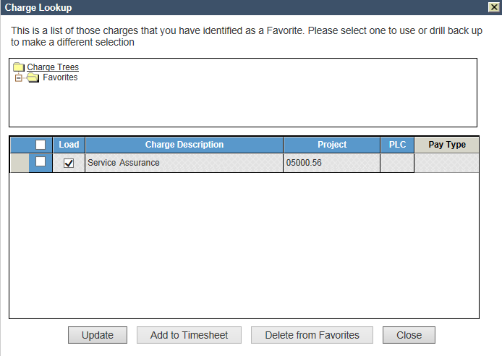

Figure –: Load Check Box

### Correct Saved Timesheet

You can adjust a saved timesheet using the reversal method. To correct a timesheet that has been saved, but **not submitted**, complete the following:

1. In the Timesheet window, locate the **incorrect entry** and select the **corresponding** check box.
2. Click **Reverse Line**.

* **NOTE**: The errant row shows the original entry, and the new row shows the reversal (as a negative).

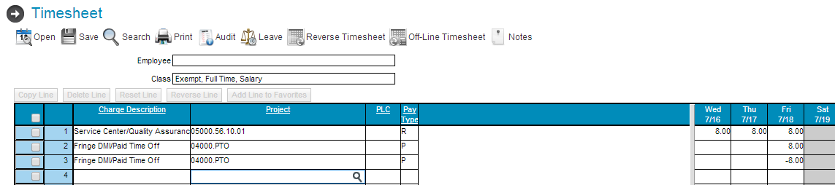

Figure –: Reverse Line Option

1. Make the necessary corrections using an existing charge row or adding a new one.
2. Click **Save**.
3. In the Revision Audit pop-up window, in the Explanation field, enter the **[reason]** for the change.

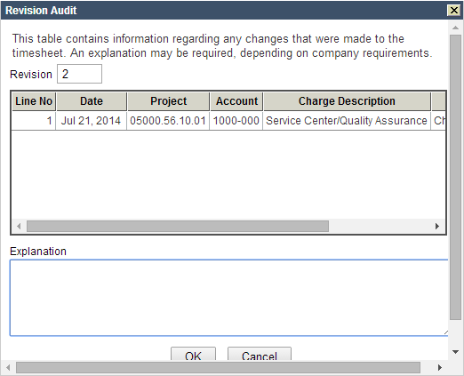

Figure –: Revision Audit Pop-Up Window

### Resolve Unavailable Charging

If a project needed for charging is not found in your lookup folders, contact your supervisor for the appropriate work authorization.

## Sign Timesheet

The timesheet must be signed at the end of the pay period. To sign a timesheet, complete the following:

1. In the Timesheet window, click the sign  icon in the lower left corner.
2. In the confirmation window, enter your **[password]** as your electronic signature.
3. Click **OK**.
4. In the Status field, verify that the status is **Signed**.

* **NOTE**: If a signed timesheet needs to be changed, make the necessary changes and re-sign the timesheet. Do not change a timesheet, after it has been approved by the supervisor, without appropriate authorization and notification.

## Adjust Work Schedule

To adjust your work schedule, complete the following:

1. In the My Desktop window, click **Time** in the upper left corner.
2. In the left navigation, expand **Schedule**, and click **Employee Work Schedule**.
3. In the Employee Work Schedule window, select the **date of the holiday** and click **Edit Date/Day of Week Properties**.

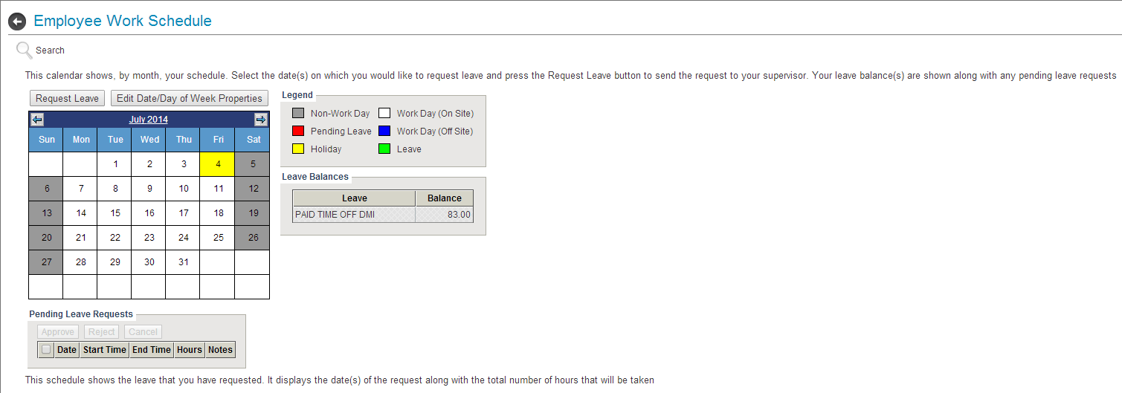

Figure –: Employee Work Schedule Window

1. In the Date Properties pop-up window, in the Properties pane, select the **Flexible** check box.

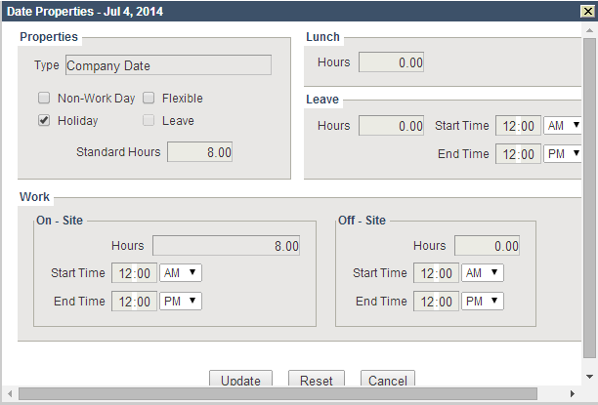

Figure –: Date Properties Pop-Up Window

1. Click **Update**.

* **NOTE**: You are now able to sign the timesheet without the error. If you get a warning, that is okay, the timesheet can still be signed.

## Correct Signed Timesheet

To correct a signed timesheet **prior to processing**, complete the following:

1. In the Timesheet window, in the Semi Monthly Peiod Ending field, click the  **toggle** links to select the *Signed* timesheet you would like to update.
2. Locate or select the **project**, and enter or update **[your hours worked]**.
3. Click **Save**.
4. In the Revision Audit pop-up window, in the Explanation field, enter the **[reason]** for the change.



Figure –: Revision Audit Pop-Up Window

* **NOTE**: The Status fields reverts to Open status.

1. In the Timesheet window, click the sign  icon in the lower left corner.
2. In the confirmation window, enter your **[password]** as your electronic signature.
3. Click **OK**.
4. In the Status field, verify that the status is **Signed**.

## Charge Future Hours

Future charging is the ability to log *leave* hours in advance. T&E allows future charging only on fringe projects (PTO and holiday). To locate the appropriate benefit charge code, perform the look up as described in Section 5.4, Record Time (i.e., go to the next available project line, click the magnifying glass, and then click Execute). T&E will provide the list of project charge codes to which you have access.

## View, Approve, or Reject Employee Timesheet

Supervisors have access to employee timesheets. If you are a designated timesheet supervisor, the search function on the control bar of the Timesheet window is enabled. To access an employee timesheet, complete the following:

1. In the Timesheet window, click **Search**.
2. The Timesheet Search window, from the Schedule drop-down menu, select **Semi-Monthl**y.
3. Select a **Year** from the drop-down menu.
4. From the Period drop-down menu, select a **timesheet period**.

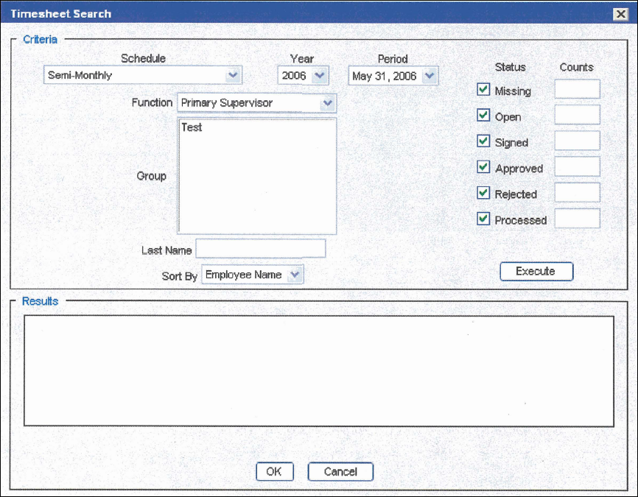

Figure –: Timesheet Search Window

1. From the Function drop-down menu, select your **functional role** (preset by the timesheet administrator).
2. In the Group field, select the **timesheet groups** of the employees you wish to view.
3. In the Status field, select the **timesheet status** check box(es) you are tracking.
4. Click **Execute**.

* **NOTE**: A list of the employees meeting the selected criteria appears in the Results pane.

1. Select an individual employee by selecting the **corresponding** check box, or select ALL by selecting the **top** check box.
2. Click **OK** to load the timesheet(s).

* **NOTE**: Once loaded, a supervisor can view, approve, or reject an employee’s timesheet.

1. Review the employee’s timesheet for accuracy.

* **NOTE**: Only signed timesheets may be approved or rejected.

1. To approve a timesheet, click the **approval**  icon in the lower right corner.

**–OR–**

1. To reject a timesheet, click the **reject**  icon in the lower right corner.

* **NOTE**: If multiple timesheets were loaded in step 10, once you have approved or rejected a timesheet, the next employee’s timesheet loads.

## View Charge Activity

The Charge Activity window enables the supervisor to review project charging activity by charge or group. To run the report, complete the following:

1. In the My Desktop window, in the left navigation, expand **Analyze**, and click **Charge Activity**.

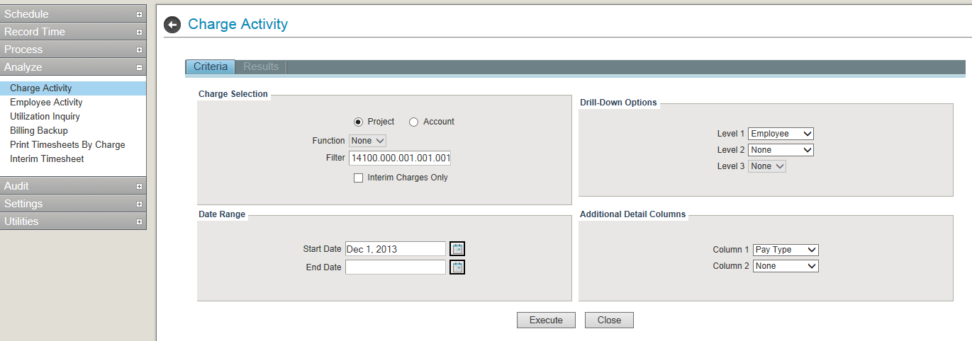

Figure –: Charge Activity Window

1. In the Charge Activity window, in the Charge Selection pane, from the Function drop-down menu, select your **functional role** (project manager).
2. If needed, in the Filter field, enter a **[value]** to narrow the report scope.
3. In the Date Range pane, in the Start Date and End Date fields, click the **calendar** icon and select **dates**.
4. If needed, in the Additional Detail Columns pane, from the Column 1 and Column2 drop-down menus, select **Account**, **Org**, **PLC**, **Pay Type**, or **None**.
5. Click **Execute**.

The results for the period selected will be grouped by project, and show the total number of hours charged by type. You can see additional details by highlighting the project row and clicking the node (+) to the left of the project name.

## Correct Processed Timesheet

To correct a processed timesheet, complete the following:

1. In the Timesheet window, in the Semi Monthly Peiod Ending field, click the  **toggle** links to select the *Processed* timesheet you would like to update.
2. Click **Reverse Timesheet**.

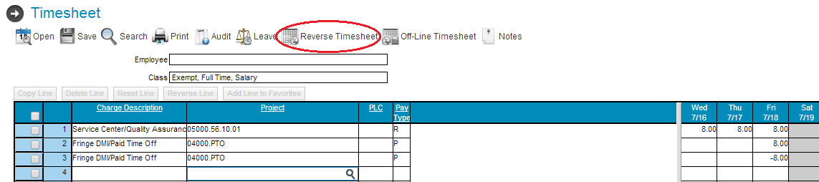

Figure –: Reverse Timesheet Option

1. Reverse entries (negatives) and new lines are populated. In the appropriate row, modify the **project account** or **hours**.
2. Click **Save**.
3. In the Revision Audit pop-up window, in the Explanation field, enter the **[reason]** for the change.

* **NOTE**: The Status fiels reverts to Open status.

1. In the Timesheet window, click the sign  icon in the lower left corner.
2. In the confirmation window, enter your **[password]** as your electronic signature.
3. Click **OK**.
4. In the Status field, verify that the status is **Signed**.

## Request or Schedule Leave

To request or schedule leave, complete the following:

1. In the My Desktop window, click **Time** in the upper left corner.
2. In the left navigation, expand **Schedule**, and click **Employee Work Schedule**.

* **NOTE**: If you are requesting or scheduling leave for someone other than yourself, click **Search** and use the Employee Work Schedule Search pop-up window to select the employee.

1. In the Employee Work Schedule window, to navigate to the correct month, click the **arrows** at the top of the calendar.

* **NOTE**: Alternatively, click the **month-year** link. In the Select a Date pop-up window, navigate to and select the **date**.

1. Click **each** **date** for which you want to request or schedule leave.

* **NOTE**: The selected dates are indicated by an outline around the cells. If you select the wrong dates, re-click to remove the selection.

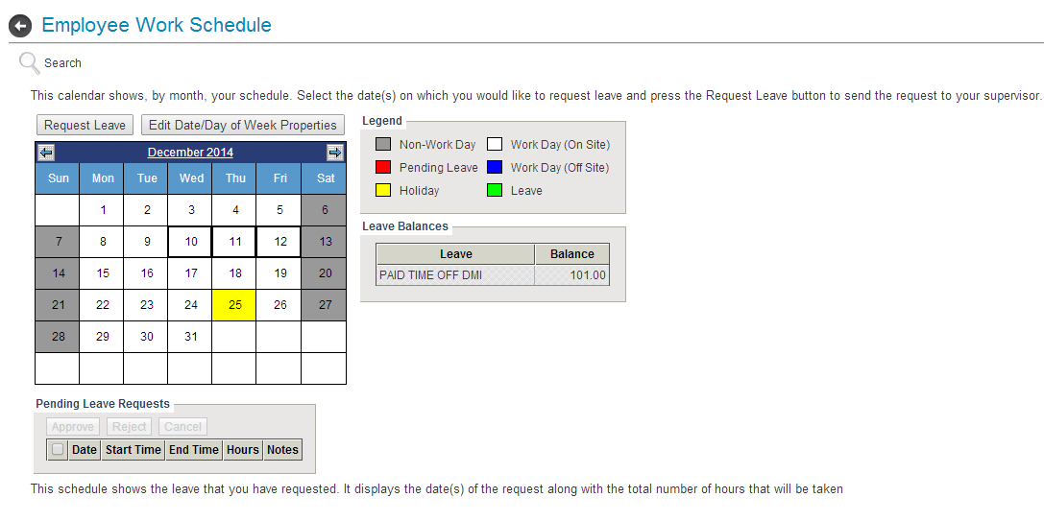

Figure –: Employee Work Schedule, Selected Dates

* **NOTE**: If your leave crosses 2 months, you must enter separate requests for the dates in each month. For example, if the requested leave is September 25th-October 4th, submit a request for September and a request for October.

1. Once all dates are selected, click **Request Leave** or **Schedule Leave**.

* **NOTE**: If you are required to request leave, the button label is **Request Leave**. If you are not required to request leave, the button label is **Schedule Leave**.

1. In the Request/Schedule Leave pop-up window, review and, if necessary, change the default **time period** and the **number of hours**.
2. In the Notes column, enter any **[explanatory notes]** related to the leave.
3. Click **OK**. The calendar indicates the days for which you have pending or scheduled leave.

## Approve or Reject Leave

To approve or reject leave an employee has requested, complete the following:

1. In the My Desktop window, click **Time** in the upper left corner.
2. In the left navigation, expand **Schedule**, and click **Employee Work Schedule**.

* **NOTE**: If the approval task appears on your Desktop, you can also open the Work Schedule screen by launching that task.

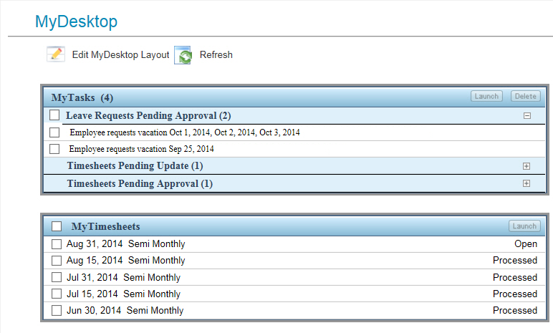

Figure –: MyTasks Leave Requests

1. If the correct employee's schedule is not displayed, click **Search** and use the Employee Work Schedule Search pop-up to select the **employee(s)**.
2. In the Employee Work Schedule window, to navigate to the correct month, click the **arrows** at the top of the calendar.

* **NOTE**: Alternatively, click the **month-year** link. In the Select a Date pop-up window, navigate to and select the **date**.

1. To approve leave requests:
2. Under Pending Leave Requests, select the check box corresponding to **each approved day**.
3. Click **Approve**.

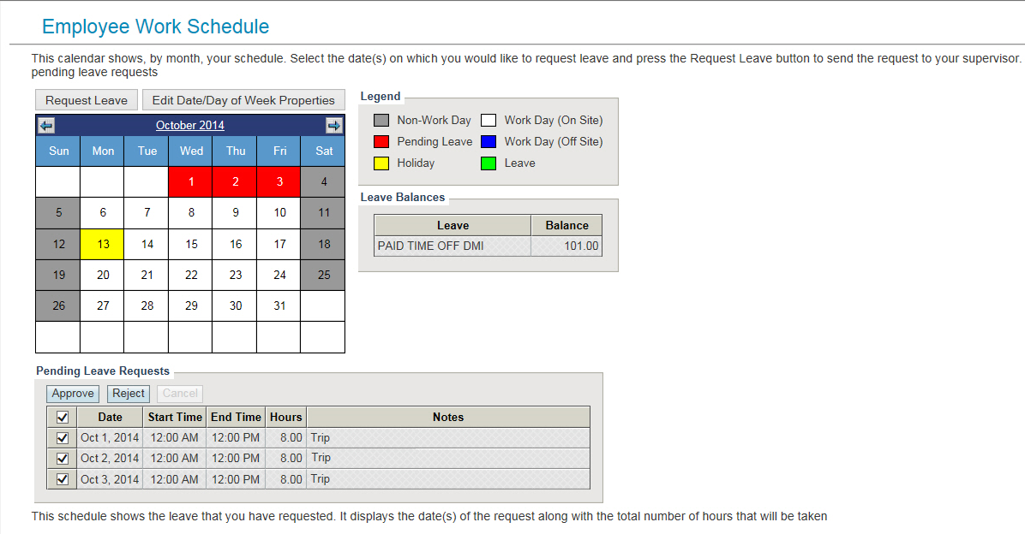

Figure –: Approve Pending Leave Requests

**–OR–**

1. To reject leave requests:
2. Under Pending Leave Requests, select the check box corresponding to **each rejected day**.
3. Click **Reject**.
4. In the Reject Vacation Request pop-up window, enter an **[explanation]** for the rejection.
5. Click **OK**.

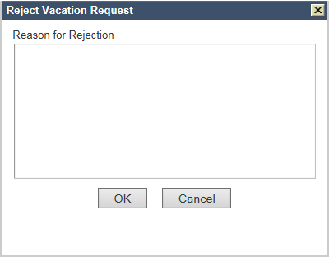

Figure –: Reject Vacation Request Pop-Up Window

* **NOTE**: If you select multiple employees in step 2, you can approve or reject those leave requests in the multiple-employee view.

## Cancel Requested Leave

If you requested leave that has not yet been approved, and you now want to cancel that request, complete the following:

1. In the My Desktop window, click **Time** in the upper left corner.
2. In the left navigation, expand **Schedule**, and click **Employee Work Schedule**.
3. In the Employee Work Schedule window, to navigate to the correct month, click the **arrows** at the top of the calendar.

* **NOTE**: Alternatively, click the **month-year** link. In the Select a Date pop-up window, navigate to and select the **date**.

1. In the Pending Leave Requests section, select the check box corresponding to **each day of leave you want to cancel**.
2. Click **Cancel**.

* **NOTE**: There is no cancellation confirmation; cancellations are final.

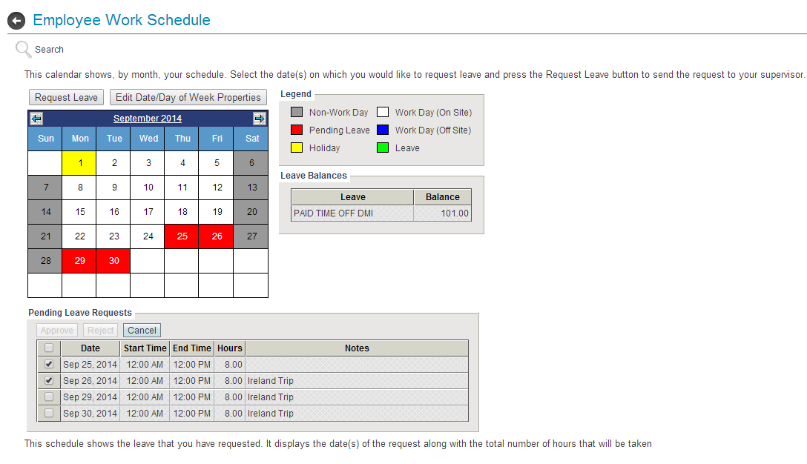

Figure –: Pending Leave Requests Section

# Definitions of Acronyms and Terms

The following table lists the terms related to this guide.

Table 5–1: Acronyms and Terms

| Term | Definition |
| --- | --- |
| ADP | Automatic Data Process |
| comp | compensatory |
| DCAA | Defense Contract Audit Agency |
| DOB | date of birth |
| DOL | Department of Labor |
| HR | human resources |
| LWP | leave without pay |
| PTO | paid time off |
| T&E | Time & Expense 9 |
| URL | uniform resource locator |